**E-Shule Modifications**

We have implemented a couple of changes as per our discussion below is some screenshots of the areas changed:

* **FrontPage:**

We have replaced with a full width slider, removed the unwanted bottom section.

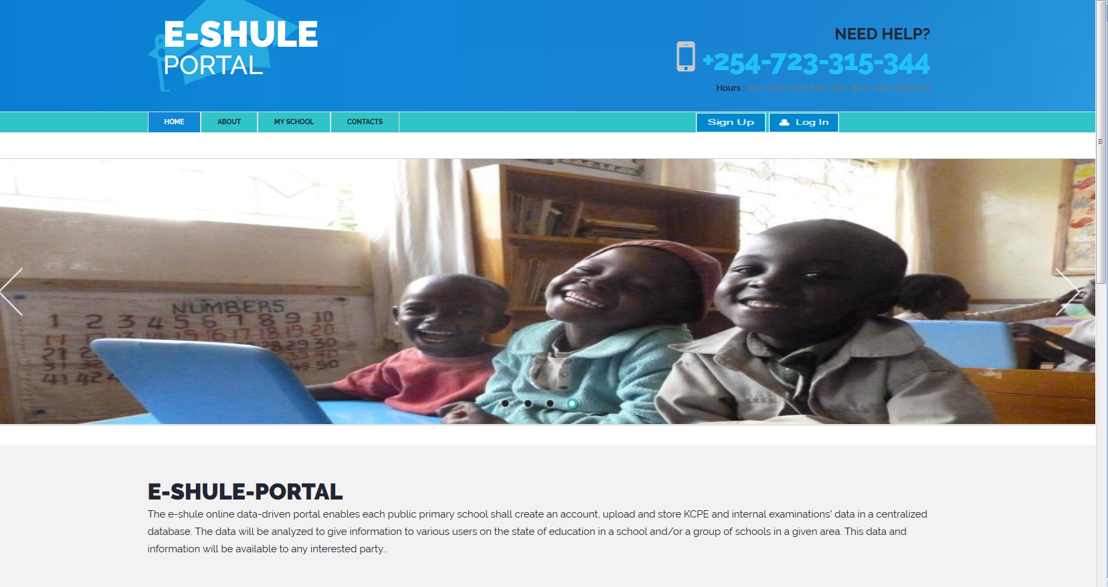

A dependent lookup with sub county filter has been set as below:

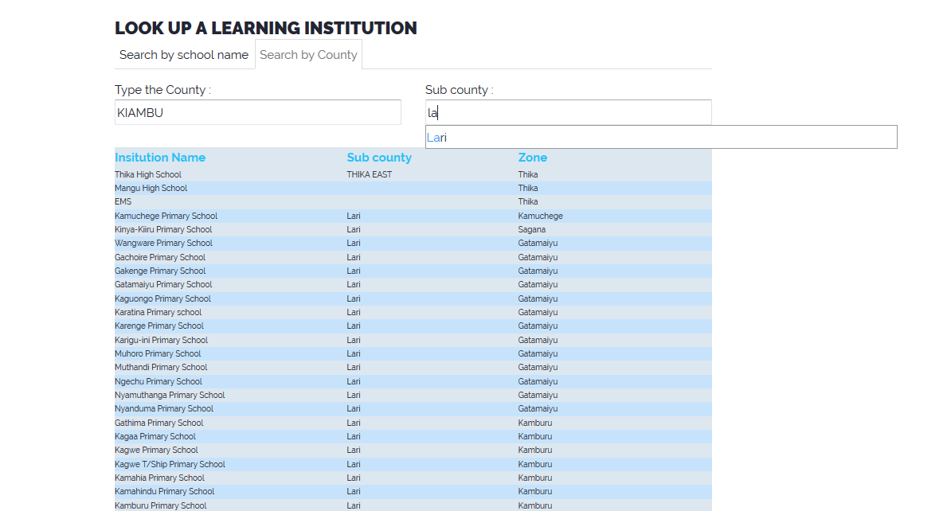

Additional system privileges for the AEO, SCEO, CDE, CS / PS, an additional module has been added for users with special privileges.

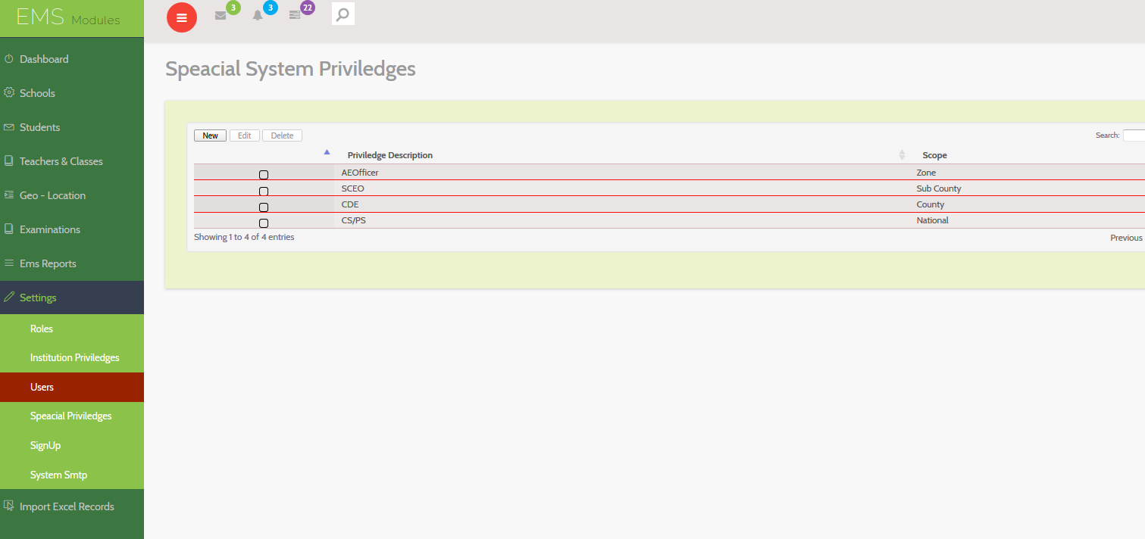

The additional privileges is directly linked to the staff where there is a section to select the type of special privilege

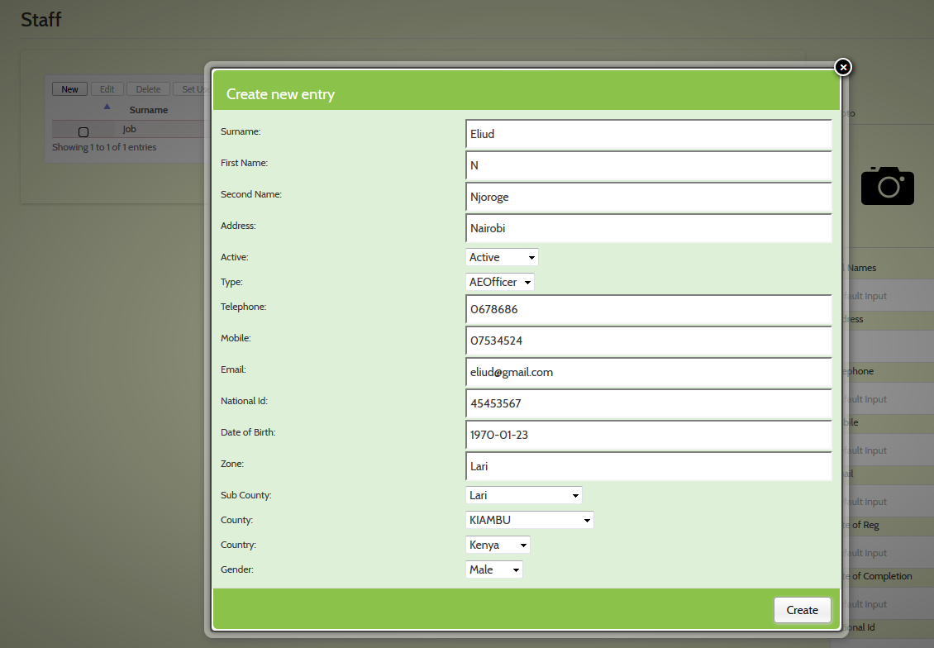

The teachers section has been improved according to the suggestions, job number, qualification etc as below:

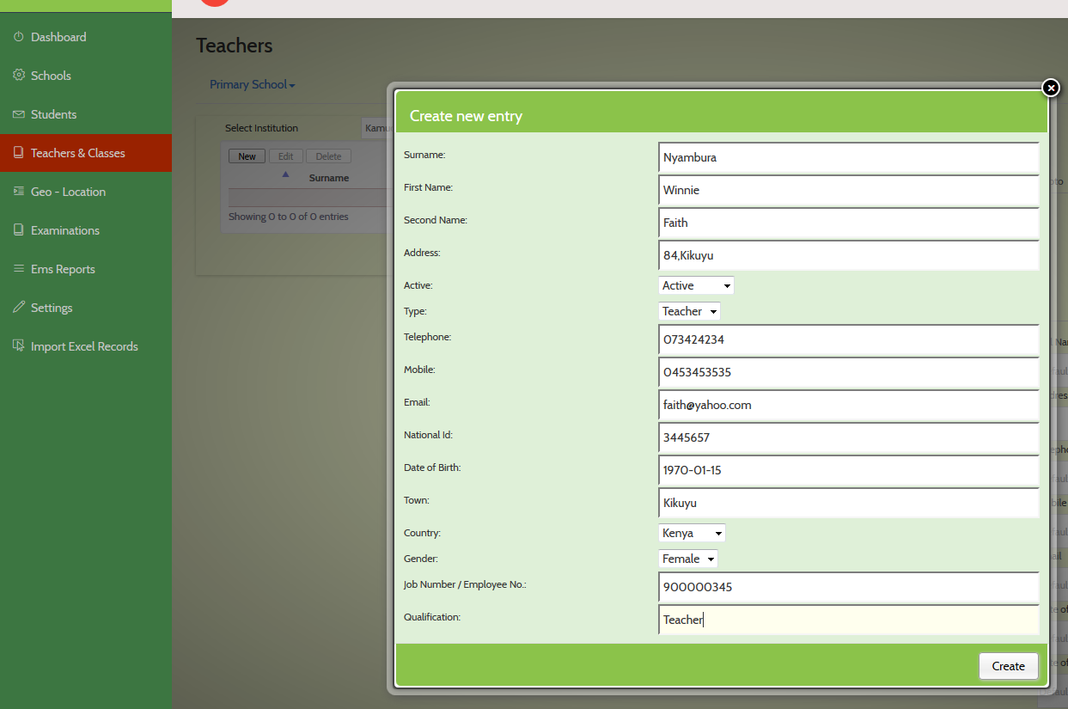

The staff section has included a popup where you can reset a user password or issue password to the staff.

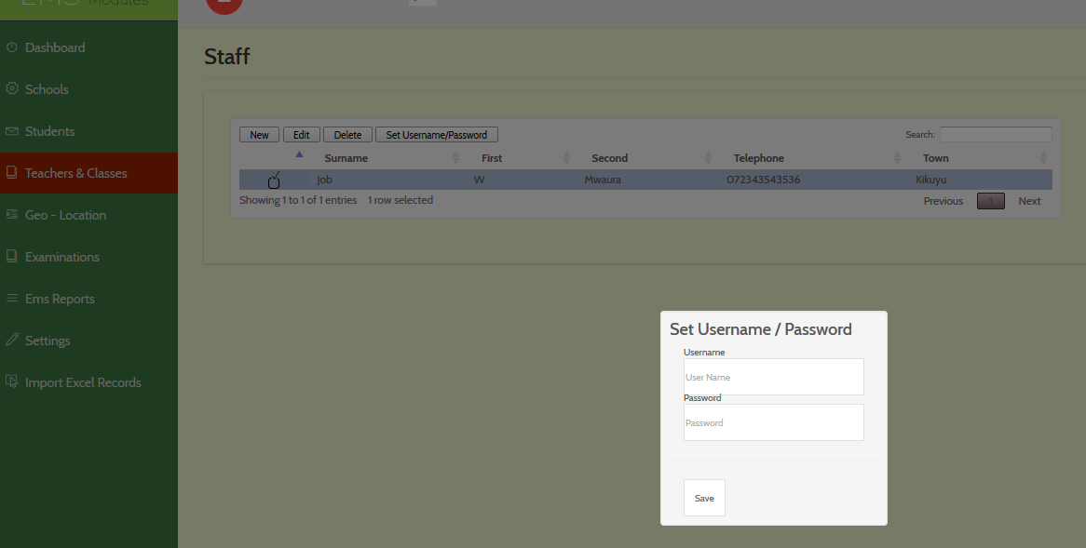

An additional module has been created, this where you map a certain user to the institution he/she can access, to assign a user to an institution, select the user and click the red button which will indicate where the user is mapped.

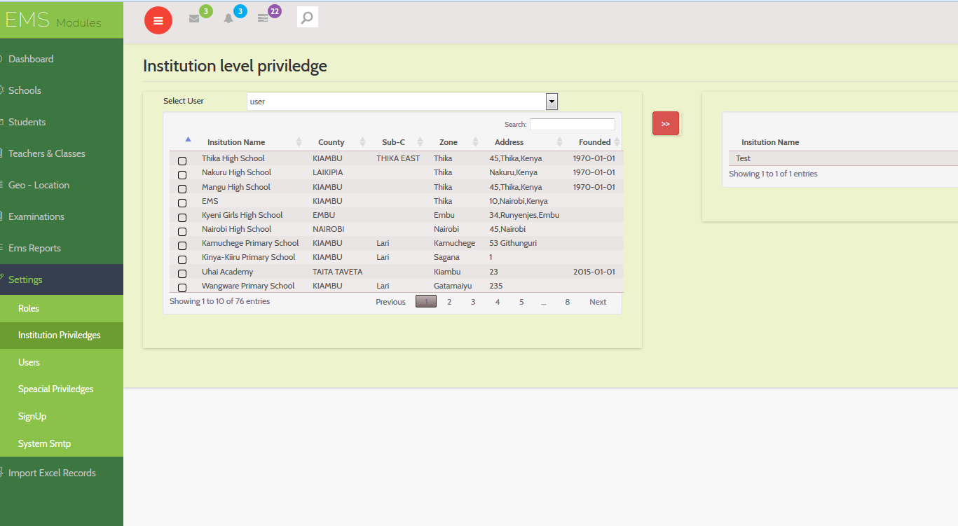

More modules have been added for the special users (AEO, SCEO, CDE, and CS/PS)

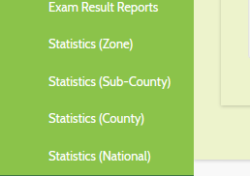

The reports are as shown below:

The report below will generate the schools for the special user who is able to see schools in the zone, note the number of the male and the female users.

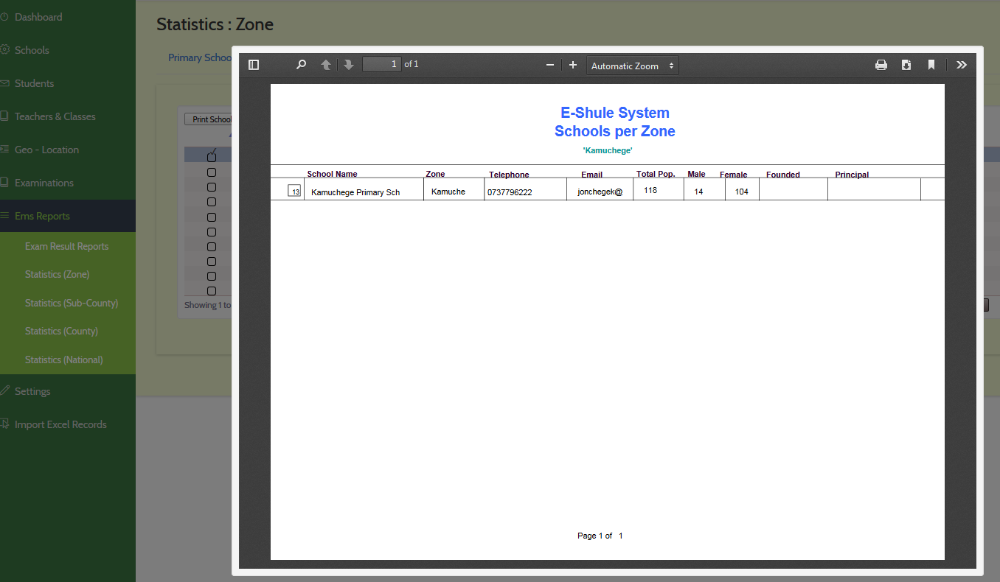

Same applies for the teachers in that zone, a Pdf output is generated:

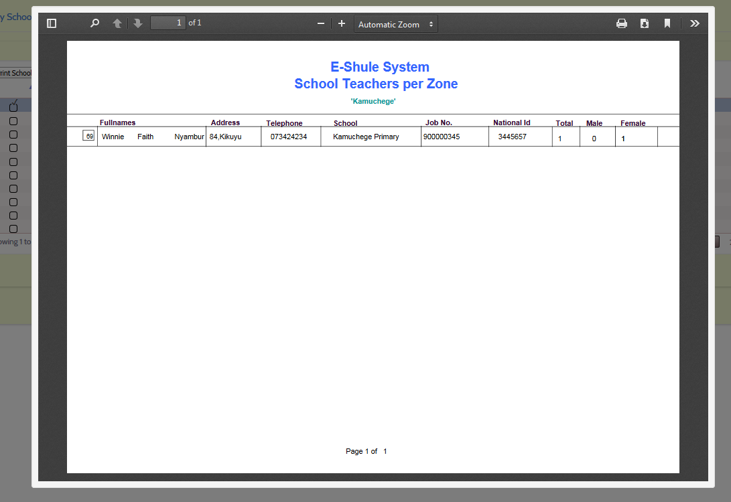

County pdf can be generated to display the schools in that sub county

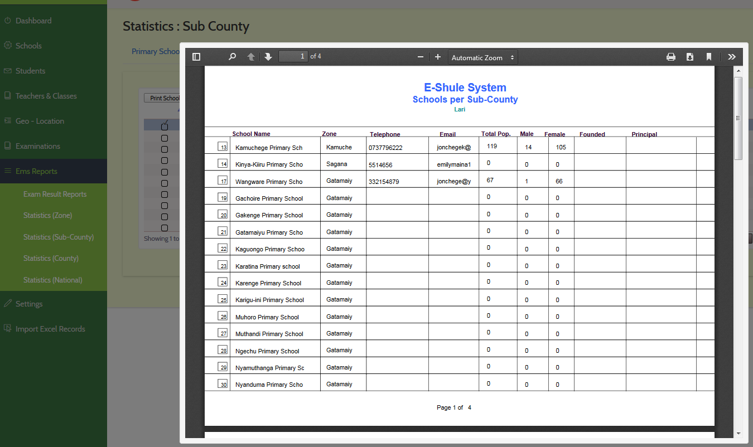

Below is a preview of the teachers in that sub county

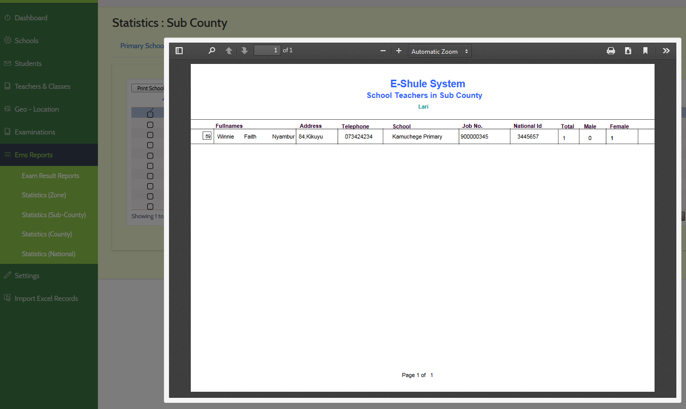

Schools in the county pdf is as displayed

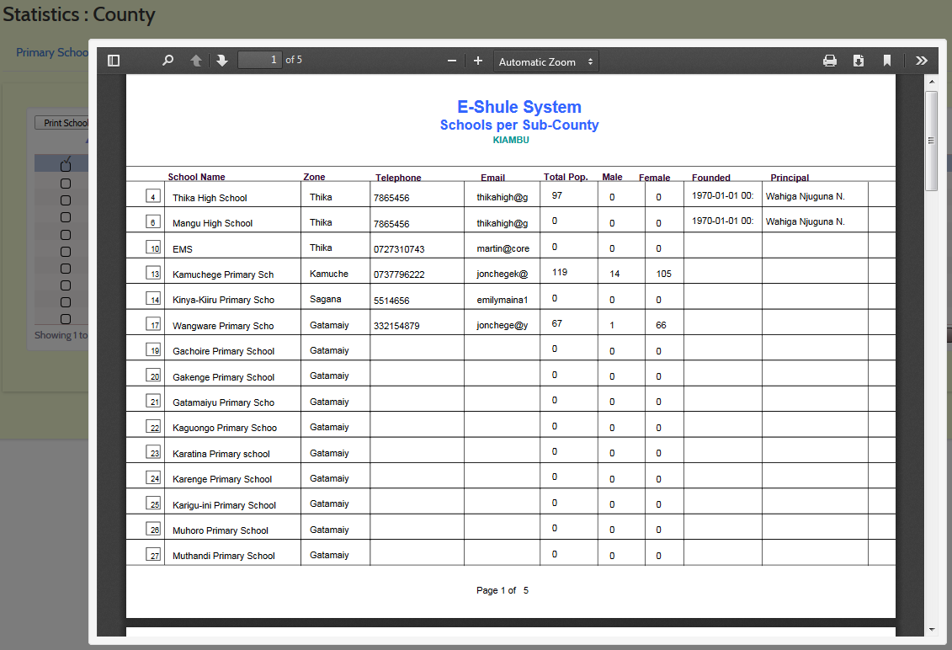

Teachers in the county as below:

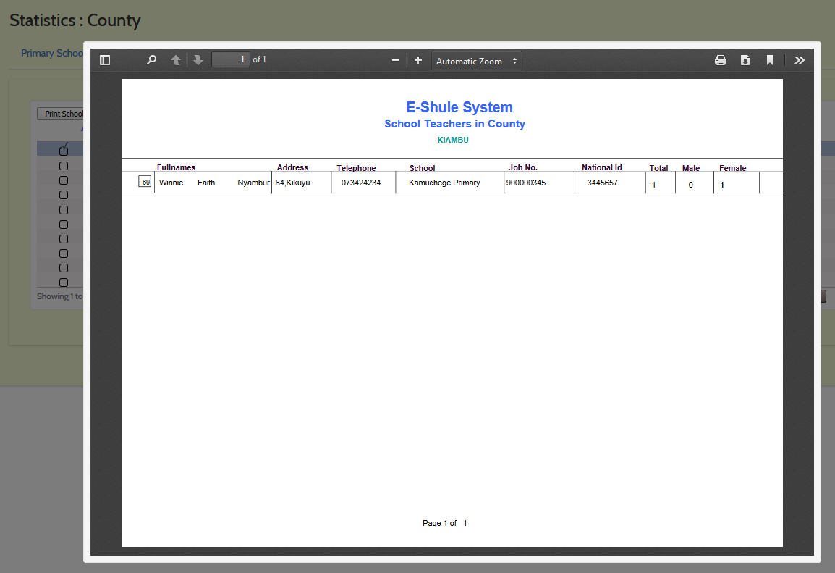

*NB: Performance Reports are on progress and an update will be issued on detailed analysis zone/sub county/county/national*